LAUGH FOR LIFE COMEDY 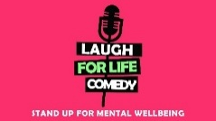
SPONSORSHIP /PARNERSHIP PACKAGE
"To bring laughter and a smile to individuals who need to have their confidence increased, learn a skill, and become part of a special community."
Introduction
Laugh For Life Comedy (LFLC) is a Liverpool-based Community Interest Company (CIC) founded by Henry Churney, a stand-up comedian with over a decade of experience.

After serving for three years as a Mental Health Lead for a global pharmaceutical company—managing wellbeing initiatives across 16 countries—Henry combined his corporate expertise with his passion for comedy and mental health. The result is a unique 5-week comedy course program that takes individuals from the classroom to a professional stage, using the medium of stand-up comedy as a tool for recovery, confidence, and community building.

On completion of the course all individuals are invited to join the Laugh For Life Creative Comedy Workshop. Each month we continue with writing and performing. This enables us to perform more, such as Buxton & Edinburgh Fringes, local shows including Liverpool Fringe. and continue the journey of stand-up helping mental wellbeing.
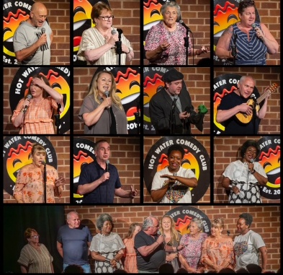
The Laugh For Life Comedy Impact 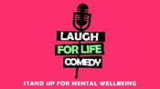
Our course is more than just learning jokes; it is a transformative experience designed to:
• Build Confidence: Empower individuals to find their voice.
• Enhance Skills: Improve presentation, writing, and active listening.
• Foster Growth: Provide professional and personal development through team building.
• Combat Isolation: Create lasting friendships and a supportive "Comedy Creative" community.
• Drive Recovery: Directly improve mental wellbeing for participants and their wider circles of family and friends.
Success & Visibility
We are a growing force in the UK arts and wellbeing scene. Our participants have performed at prestigious venues and festivals, including:
• The Edinburgh Fringe Festivals (2025 & 2026)
- The Buxton Fringe Festivals (2025 & 2026)
- The Epstein Theatre, Liverpool
• The Liverpool Fringe (2025)
• Weird and Wonderful Festival (2026)

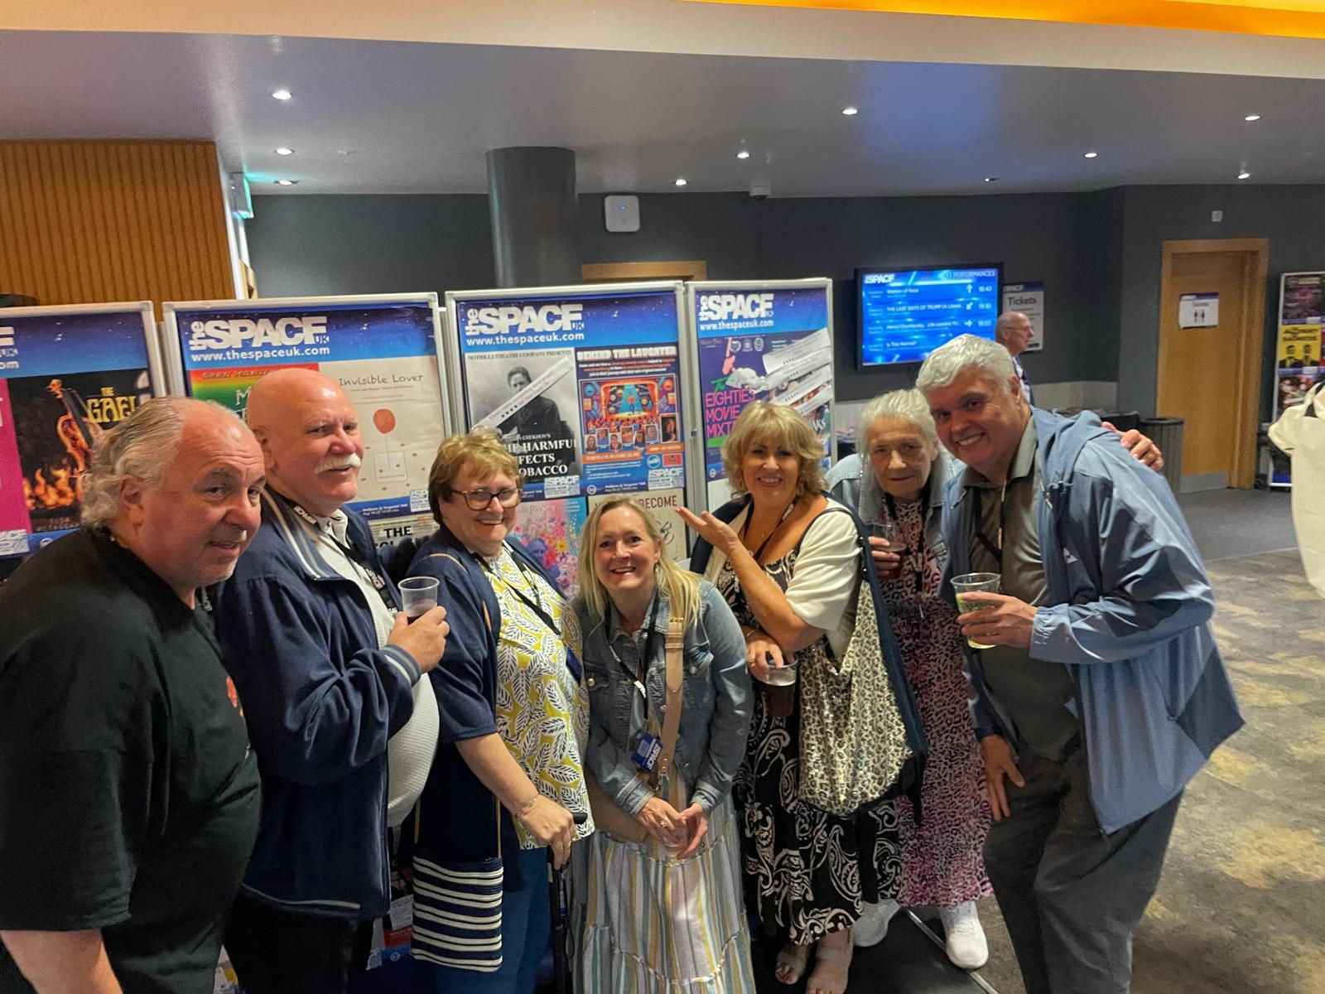

WHY SPONSOR LFLC? 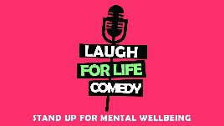
By partnering with LFLC, your organization supports a proven model that helps vulnerable people rejoin their communities with renewed purpose. Your sponsorship directly funds more courses and provides platforms for performers to travel and share their stories nationwide.
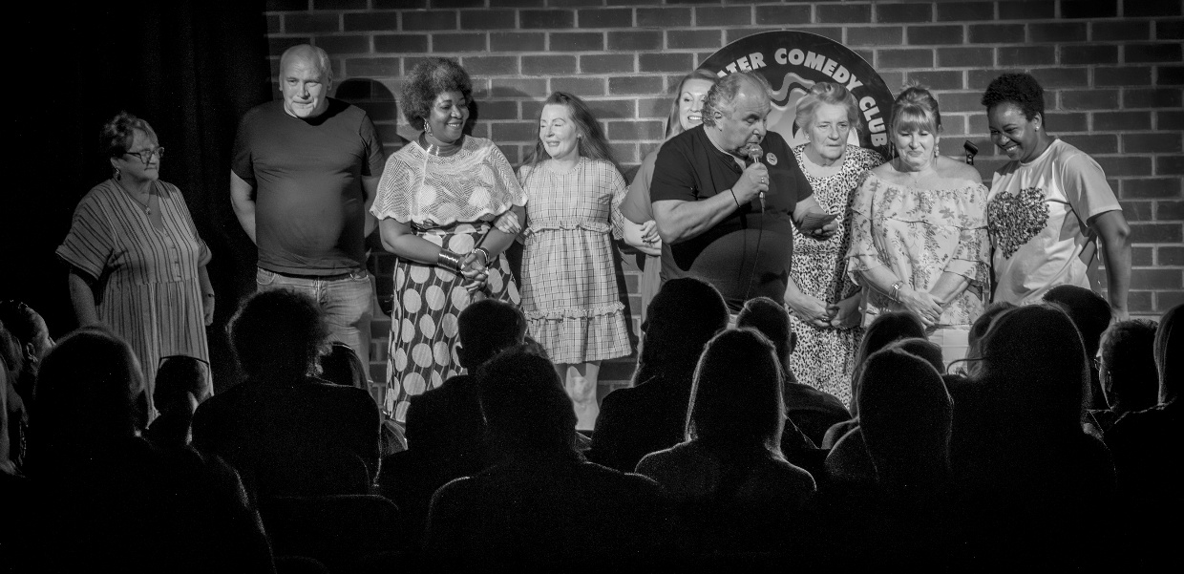
Corporate Social Responsibility (CSR) Benefits:
1. Community Impact: Back a grassroots Liverpool CIC making a tangible difference in mental health.
2. Brand Visibility: Reach diverse audiences at high-profile festivals and local showcases.
3. Employee Wellbeing: Access exclusive corporate workshops that use comedy techniques to improve your team's communication and mental health.

IMPACT STORY
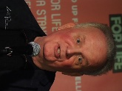
The LFL course & the subsequent live shows have hugely benefited my recovery from serious mental health problems, for which I was sectioned three times. The sense of achievement was enormous. It’s a wonderful feeling to make a room full of people laugh and it has greatly increased my self-confidence and sense of
worth. (Richard R)

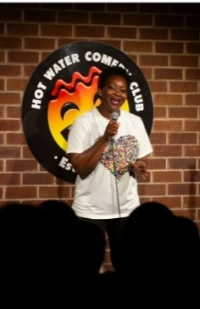
I suffer from low mental health due to a traumatic childhood and severe abuse in my marriage…so coming to this comedy course has helped, we laugh which I thought I’d never do again. Thanks Henry…amazing opportunity of a lifetime. (Happy O)

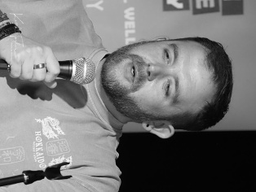
Thank you once again for the opportunity to do that last night. You have done something for me I could never have dreamed of doing myself and I truly appreciate that. (Tom Mc)

SPONSORSHIP PACKAGES
LEAD SPONSOR - £3,000
- “Founding Partner” Badge
- Logo on internal advertising banners
- An advertising board at showcases & Festivals
- 5 social media posts across our platforms
- 12 complementary tickets to showcase and first drink
- On stage speaking opportunity at showcases
- Mention in any press and PR advertising
- Filmed interview
- ONE Free corporate seminar workshop for company
GOLD SPONSOR - £2,000
- Logo on internal advertising banners
- An advertising board at showcases & Festivals
- 5 social media posts across our platforms
- 10 complementary tickets to showcase and first drink
- Mention in any press and PR advertising
- 50% discount on a corporate seminar workshop for company
SILVER SPONSOR - £1,000
- Logo on internal advertising banners
- An advertising board at showcases
- 3 social media posts across our platforms
- 4 complementary tickets to showcase and first drink
- Mention in any press and PR advertising
- 20% discount on a corporate seminar workshop for company

BRONZE SPONSOR - £500
- Logo on internal advertising banners
- 2 social media posts across our platforms
- 2 complementary tickets to showcase
- 10% discount on a corporate seminar workshop for company
CONTACT AND NEXT STEPS
We are seeking partners who want to create a legacy of happiness and health across Merseyside and beyond. Join us as we expand our reach to more charities, healthcare organizations, and social prescribers.

Get involved today:

Contact: Henry Churney

Email: henry@laughforlifecomedy.co.uk

Mobile: 07595692016

Website: www.laughforlifecomedy.co.uk

Social Media: churney henry & laugh for life comedy (FB): hcbluenose1 (Insta)
@hcbluenose (X)

Laugh For Life Comedy CIC – Stand Up For Mental Wellbeing.
